Phase 2: Org Setup & Configuration
Project: Smart City Citizen Helpdesk & Engagement Platform
Prepared by: B. V. Manasa

1. Salesforce Editions
For this project, the Salesforce Enterprise Edition (Developer Org) is used since it provides:
- Service Cloud features (Case Management, Omni-Channel, Knowledge Base)
- Experience Cloud (Citizen Portal)
- Field Service Lightning (task assignment for city workers)
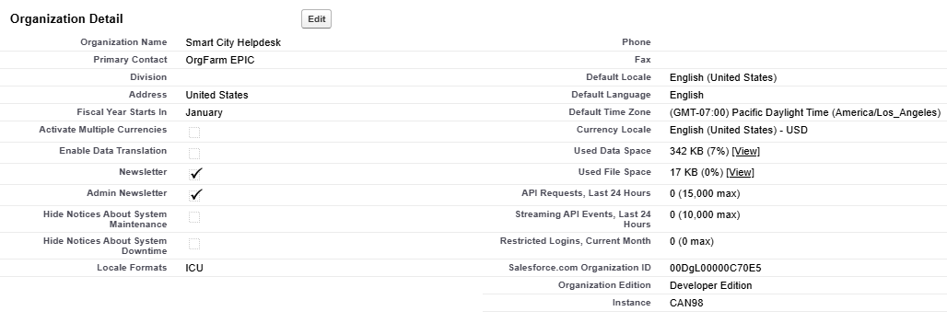
- Einstein AI (for categorization & prioritization)

Our project is implemented on Salesforce Developer Edition, which provides access to Service Cloud, Experience Cloud, and customization features required for building the Smart City Citizen Helpdesk

2. Company Profile Setup
- Company Name: Smart City Citizen Helpdesk
- Default Time Zone: (GMT-07:00) Pacific Daylight Time (America/Los_Angeles)
- Language: English
- Corporate Information: Entered basic details for identification

3. Business Hours & Holidays
- Standard Business Hours: Mon–Sat, 9:00 AM – 6:00 PM
- Emergency Hours: 24/7 for accident/emergency cases
- Holidays Added:
  - Jan 26 – Republic Day
  - Aug 15 – Independence Day
  - Oct 2 – Gandhi Jayanti
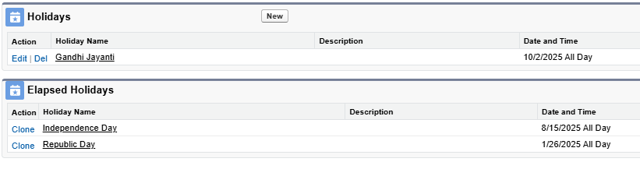
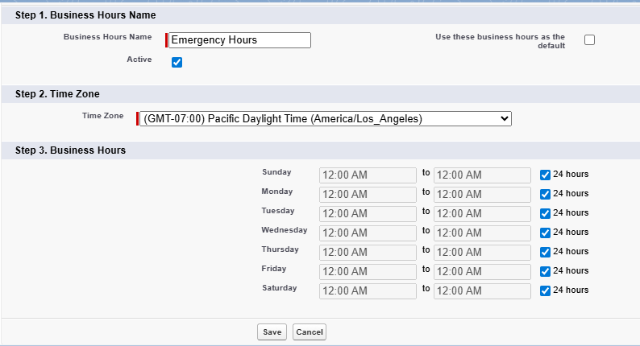
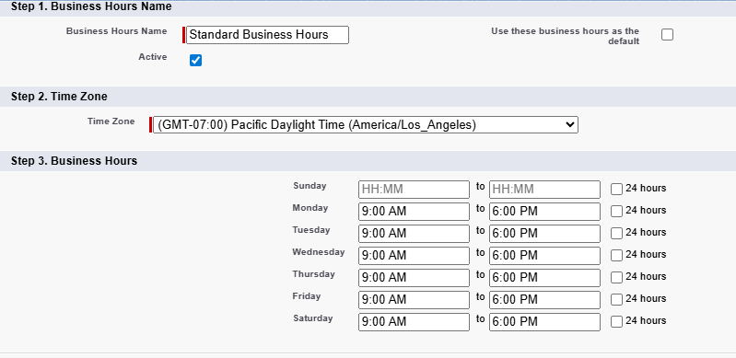

4. Fiscal Year Settings
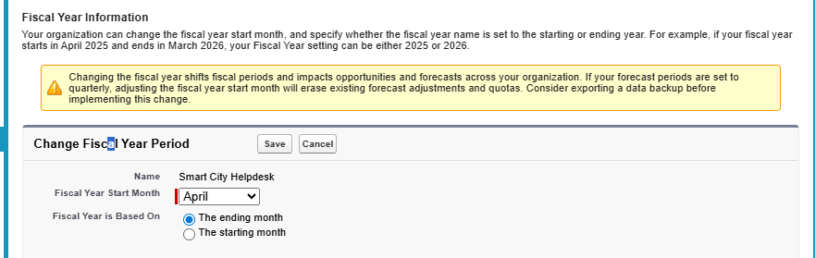
- Fiscal year follows the Indian Standard Fiscal Year: April 1 – March 31

5. User Setup & Licenses
- Created sample users:
  - Admin User → Full access
  - Citizen User → Portal access (Experience Cloud license)
  - Field Officer User → Case resolution (Service Cloud license)
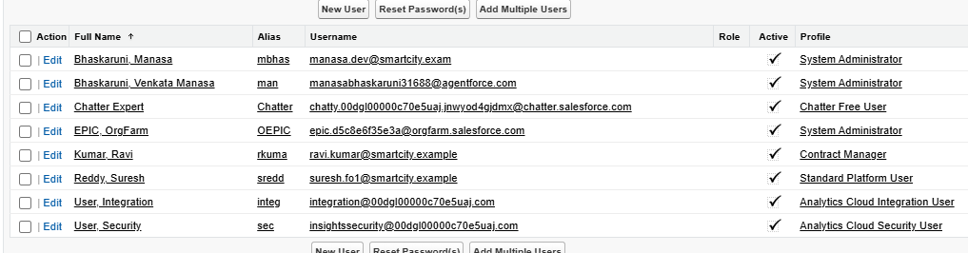
  - City Manager User → Dashboard access (Service Cloud + Reports)

6. Profiles
Profiles define baseline permissions:
- System Administrator Profile → For Admins
- Citizen Profile (Custom) → For portal users
- Field Officer Profile (Custom) → Case handling & updates
- Manager Profile (Custom) → Access to reports/dashboards

7. Roles
Roles define data visibility hierarchy:
- City Commissioner → Top role
  - Department Head (Waste, Water, Traffic, Health)
    - Field Officers

8. Permission Sets
Created to provide additional access without changing profiles:
- WhatsApp Access → For Omni-Channel messaging
- Dashboard Access → For managers who need extended reporting

9. Org-Wide Defaults (OWD)
- Cases: Private (so only owner & above roles see them)
- Knowledge Articles: Public Read-Only
- Portal Access: Controlled via Sharing Rules

10. Sharing Rules
- Shared Cases with Department Heads and Field Officers in the same department.
- Shared Reports & Dashboards with Managers.

11. Login Access Policies
- IP Ranges: Restricted access for Admin logins
- Session Timeout: 30 minutes
- Two-Factor Authentication (2FA): Enabled for all admins

12. Developer Org Setup
- Used Salesforce Developer Edition Org (free)
- Enabled Service Cloud, Experience Cloud, and Field Service Lightning

13. Sandbox Usage
- Sandbox Created: Developer Sandbox for testing
- Purpose: Configure workflows, test citizen portal, validate permissions before deployment

14. Deployment Basics
- Change Sets will be used to migrate metadata from Sandbox → Production
- Deployment Checklist:
  - Profiles & Roles
  - Permission Sets
  - Custom Objects (in later phases)
  - Workflows & Flows

